Guided Practice Report
Before completing this guided practice report, you should have completed the associated procedure.

Screenshots
After you have completed the procedure for the guided practice, add your screenshots below.
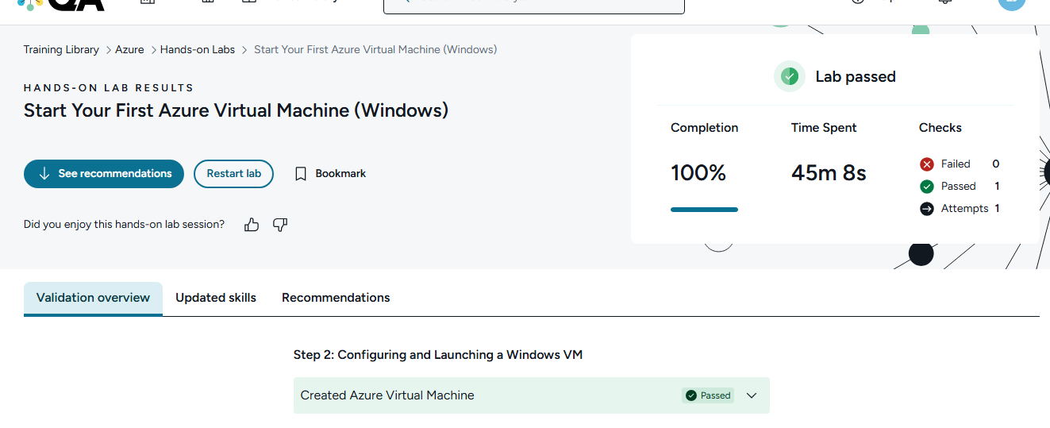

Reflection Questions
After you have completed the procedure for the guided practice, provide your answers to the reflection questions here.
Azure is the cloud computing platform of what software company?
Microsoft

What service and port did you use to remotely connect with the Windows Server you created?
Remote Desktop Protocol (RDP), port 3389

Why is this service different from the one used with AWS?
Azure Windows Server uses RDP because it’s a Windows GUI remote-access service. AWS labs often use SSH on port 22, which is mainly for Linux command-line access.

